Sri Lanka Institute of Information Technology



IE3142 – DevOps Security
Building and Securing a DevSecOps Pipeline

Sathsarani T.L.D
09/30/2026

Introduction
This section presents the application selected for the DevSecOps project and explains its architecture and containerization approach. The selected application is OWASP Juice Shop, an intentionally vulnerable open-source web application listed in the assignment's approved application list. The assignment identifies Juice Shop as a Node.js/Angular application with a frontend and backend API and provides the official Docker image bkimminich/juice-shop.

The purpose of this part is to establish a reproducible local environment in which the other group members can perform threat modelling, exploit-and-fix activities, security scanning, and CI/CD security automation. Containerization also gives the group a consistent environment for running the application during testing.

01.System Overview
1.1 Introduction to OWASP Juice Shop
OWASP Juice Shop is a free, open-source web application used for cybersecurity training and security testing. It looks like an online shopping website but contains different security weaknesses that help students learn about real-world web security problems. It is commonly used to practice finding vulnerabilities, fixing security issues, and secure software development. The application is built using Node.js, Express.js, and Angular.

1.2 Reason for Application Selection
We selected OWASP Juice Shop because it meets the main requirements of our assignment. It is an open-source application that can be run using Docker and has several components that work together. It also contains built-in security vulnerabilities, making it suitable for threat modelling, vulnerability testing, secure coding, and DevSecOps activities in a controlled environment.

1.3 System Components

The application consists of three main components:
- Frontend Layer: Provides the user interface using Angular.
- Backend Layer: Handles business logic, authentication, and API requests using Node.js and Express.js.
- Database Layer: Stores application and user-related data.
Users interact with the frontend through a web browser, and the frontend communicates with the backend using API requests. The backend processes requests and interacts with the database when required

1.4 Technology Stack

Component | Technology
Frontend | Angular
Backend | Node.js
Framework | Express.js
Language | JavaScript , TypeScript
Database | SQLite
Containerization | Docker
Version Control | Github
CI/CD | Github Action

02.Architecture and Containerization

2.1. Architecture Diagram

The architecture separates the external user/browser from the application running inside the Docker environment. A user accesses the Juice Shop through a web browser using the exposed local HTTP port. Within the application boundary, the Angular frontend communicates with the Node.js backend API. This separation represents the main application components and the data/request flow that will later be used by the group for threat modelling.

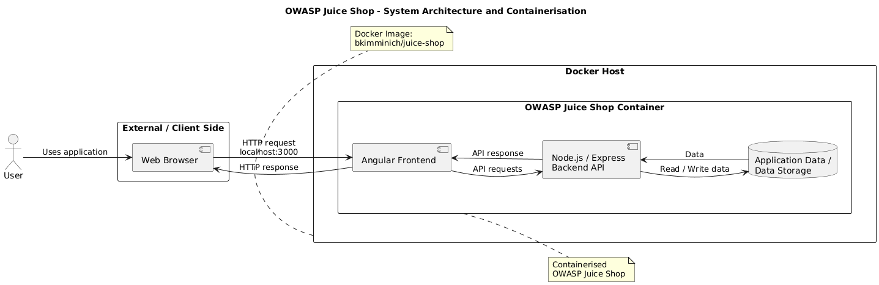

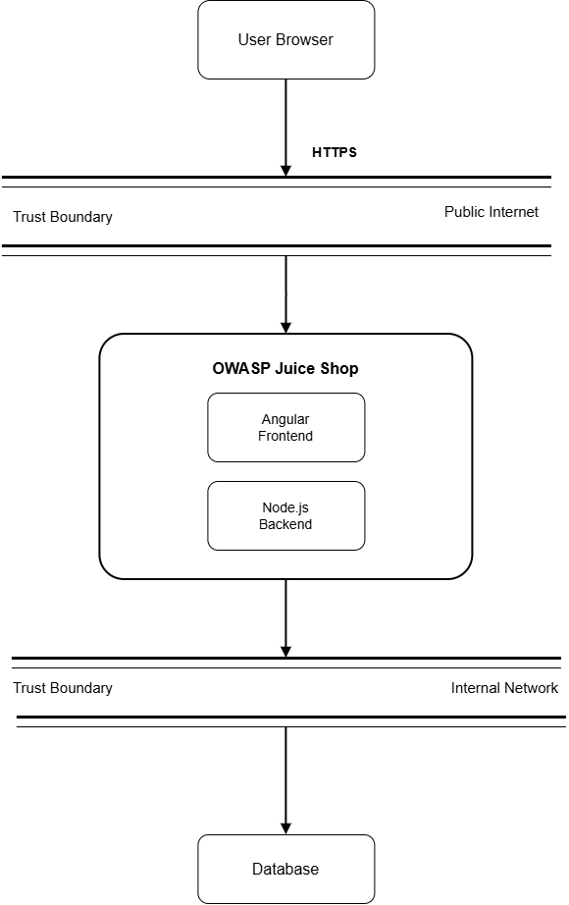

2.2. Architecture Components

- User Browser: The user interacts with the Juice Shop through a web browser. The browser is outside the Docker application boundary.
- Angular Frontend: The frontend provides the web interface presented to the user. It is the client-facing part of the Juice Shop application.
- Node.js / Express Backend API: The backend API processes application requests originating from the frontend and provides backend functionality.
- Docker Container: The Juice Shop runtime is executed inside a Docker container, providing an isolated and reproducible environment.
- Docker Image: The bkimminich/juice-shop image is the packaged application artifact from which the container is created.

2.3. Network Diagram

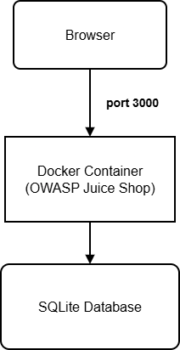

2.4. Data Flaw Diagram

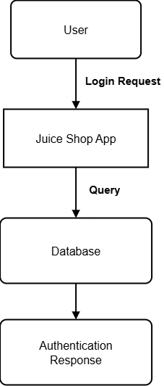

Data and Request Flow
- The user opens the Juice Shop application in a web browser.
- The browser sends HTTP requests to the locally exposed Juice Shop service.
- The request reaches the Juice Shop application running inside the Docker container.
- The Angular frontend communicates with the Node.js/Express backend API for application operations.
- The backend produces the required response, which is returned through the application to the user's browser.

3.Docker Compose Execution

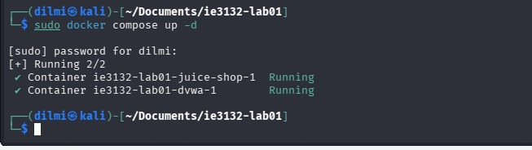

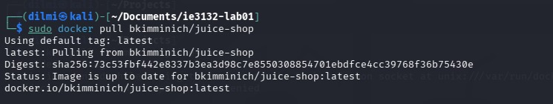

docker docker-compose.yml
services:
juice-shop:
image: bkimminich/juice-shop
ports:
- "3000:3000"
environment:
- NODE_ENV=production
networks:
- app-network

nginx-proxy:
image: nginx:alpine
ports:
- "80:80"
depends_on:
- juice-shop
networks:
- app-network
volumes:
- ./nginx.conf:/etc/nginx/conf.d/default.conf

networks:
app-network:
driver: bridge

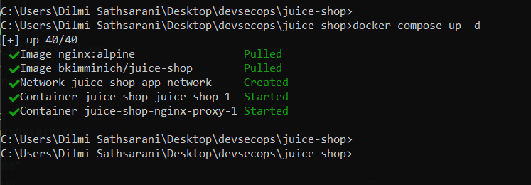

4.OWASP Juice Shop Running in Browse

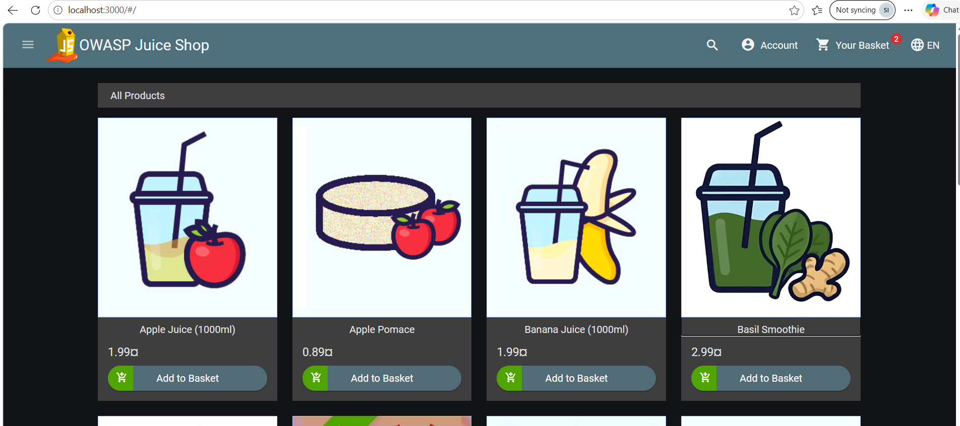

5.Trust Boundaries

Trust boundaries represent the points where data moves between components or environments with different levels of trust. Identifying these boundaries is important because they highlight areas where security threats and unauthorized access may occur.
The first trust boundary is between the external user and the OWASP Juice Shop application. Users interact with the application through a web browser, and requests coming from the browser should be treated as untrusted. This boundary may be exposed to threats such as SQL Injection, Cross-Site Scripting (XSS), credential attacks, and unauthorized access attempts. Therefore, security measures such as authentication, input validation, authorization, and secure communication should be applied to protect the application.
The second trust boundary exists between the application layer and the database layer. The backend application should be the main component allowed to communicate directly with the database. This separation helps protect sensitive information and reduces the possibility of unauthorized data access, modification, or information disclosure. Proper access controls and secure database communication should be used to protect this boundary.
In the containerized architecture, there is also a clear separation between the external client and the application environment running inside Docker. The user's web browser operates outside the Docker environment, while the Angular frontend and Node.js/Express backend operate within the Juice Shop container. Requests from the browser cross this boundary when they enter the application. Therefore, this boundary is particularly important when performing the STRIDE threat analysis, as it represents a key point where untrusted external input enters the system.

6.Conclusion
OWASP Juice Shop provides a suitable application foundation for the group's DevSecOps Security project. The assignment identifies Juice Shop as an approved intentionally vulnerable application with a Node.js/Angular stack, frontend and backend API, and an official Docker image. The application has been placed in a reproducible containerized environment, and its main components, request flow, and trust boundary have been documented. This architecture will be used as the basis for the group's STRIDE threat model, vulnerability remediation activities, and automated CI/CD security gates.

